

**Trafford Post-Acute COVID Assessment Guide for Primary Care**

**ADULTS**

**Version: 2.1 (March 2021)**

**Contents:**

**Page 2-3:** Preface and Summary of clinical features and clinical model

**Page 4-7:** Tier 2 Primary Care Post-Acute Covid-19 Management & Referral pathway to Tier 3 Post-Acute-Covid 19 Assessment Clinic

**Page 8**: Face to Face assessment Tool

**Page 9**: Appendix 1 Useful References and Tools

**Page 10-11**: Appendix 2 Services available in Trafford to support patients with Post -Acute Covid-19 in the community (Tier 1 and Tier 2)

**Page 12**: Appendix 3 Referral pathway to access practical, psychological and mental health support post Covid

**Page 13-14:** Appendix 4 Copy of Post-Acute Covid-19 Assessment Service referral template

**Page 15:** Appendix 5 MFT Post-Acute COVID Referrals to Tier 3 Secondary Care Service

**Preface**

We are delighted to introduce/streamline services to see patients who still have persisting symptoms following COVID-19.

Patients with persisting symptoms after the first 4 weeks since onset of symptoms fall into three broad categories:

* People who initially had severe disease (usually hospitalised or in intensive care), and now have significant long-term organ damage, weakness and disability;
* People who had milder disease in the acute stages of infection, but who also now have some evidence of long-term organ damage; and
* People who have persistent symptoms, but don’t have persisting organ damage.

The people who were hospitalised are usually followed up at 4 to 6 weeks interval and further investigations are carried out to look for any long-term damage. This leaves a gap for those patients who were managed by GPs either on their own or with support of hot clinics and oxygen monitoring services at home.

This service opens referral routes for patients who still have symptoms after 4 weeks. The symptoms of post Covid-19 are very common symptoms, like breathlessness, tiredness, cough and they could easily be symptoms of other conditions like lung cancer or new onset type 2 Diabetes. It is really important to carry a thorough clinical assessment, and investigations as appropriate to rule out other diagnosis before attributing symptoms to Post Covid-19.

The Post Covid-19 service model is a tiered model as recommended NHS England and by Greater Manchester Health and Social Care Partnership (GMHSCP) and is outlined in the figure 1.1 below. The principles of management are as below:

* Confirm the diagnosis (medical assessment, not dependent upon a positive test result;
* Exclude other serious conditions;
* Support & monitor the patient (whilst avoiding over-investigation/over-referral);
* Direct patients to assessment clinics, if appropriate.

This guideline has been developed in partnership across Manchester and Trafford Clinical Commissioning Groups, Manchester Foundation Trust and Manchester and Trafford Local Care Organisation. As always, we hope you find the guidelines useful.

**Dr Murugesan Raja**

MHCC

**Dr. Manish Prasad**

TCCG

On behalf of Manchester & Trafford post Covid 19 Steering Group

**4-Tier Integrated Service Model**



**Fig 1.1**

**Tier 2 Primary Care Post Acute Covid Management**

Post acute effects of COVID as per the definitions below. This diagnosisshould be considered in someone who has had suspected or confirmed acute COVID-19. A positive test is not a prerequisite for considering the diagnosis since the test has a significant false negative rate. Also, community testing was not always available, so a clinical diagnosis has often been made.

**Primary care coding:**

**SNOMED CT code: Acute COVID-19 infection**

Signs and symptoms of COVID-19 for less than 4 weeks.

**SNOMED CT code: Ongoing symptomatic COVID-19**

Signs and symptoms of COVID-19 from 4 weeks up to 12 weeks.

**SNOMED CT code: Post-COVID-19 syndrome**

Signs and symptoms that develop during or after an infection consistent with COVID-19, continue for more than 12 weeks and are not explained by an alternative diagnosis. It usually presents with clusters of symptoms, often overlapping, which can fluctuate and change over time and can affect any system in the body. Post-COVID-19 syndrome may be considered before 12 weeks while the possibility of an alternative underlying disease is also being assessed.

**Management:**

Depending on the presenting symptoms, management may include:

• Immediate, on-the-day referral for red flag symptoms or signs.

• Advice on self-management.

• Onwards referral

Refer immediately (same day) if suspected acute/life-threatening complication, e.g.:

• Severe hypoxaemia/oxygen desaturation on exercise

• Signs of severe lung disease

• Cardiac chest pain

• Severe psychiatric symptoms/risk of suicide.

• Multisystem inflammatory syndrome in children

This diagnosis is a diagnosis of exclusion, and all relevant investigations should be carried out before reaching it.

**Quick summary Tier 2 Primary Care Post Acute Covid Management**

People who had contact with healthcare services during or after suspected or confirmed acute COVID-19 infection (and their families or carers) should be given written information on:

* what to expect during their recovery;
* symptoms to look out for, that mean they need to be reassessed
* Trafford Covid -19 Patient Information leaflet
* who to contact if they are worried about new or continuing symptoms, especially if they have them more than 4 weeks after the start of acute COVID-19

**Post COVID Primary Care follow up Video/Telephone/ Face to Face (> 4 weeks)**

*Check for ongoing symptomatic COVID-19 (4-12 weeks) or post COVID-19 syndrome(>12 weeks), arrange appointment for review according to clinical concern and/or patient concern* about new or ongoing symptoms.

Acute services

e.g hypoxaemia or oxygen desaturation on exercise, signs of severe Lung disease, cardiac chest pain or multisystem inflammatory syndrome (in children).

GP history and examination and investigations*

to exclude alternative underlying diagnoses e.g malignancy

*<https://dx.doi.org/10.1136/bmj.m3026>

Refer to **Tier 1** services, supported self-management, Your Covid Recovery website/app <https://www.yourcovidrecovery.nhs.uk/>, peer support group, community support hubs, community care navigators and social prescribing. Further details on how to access these services in Trafford can be found in *Appendix 4* below.

Refer people with ongoing symptomatic COVID-19 or suspected post-COVID-19 syndrome urgently for psychiatric assessment if they have severe psychiatric symptoms or are at risk of self-harm or suicide.

Refer to IAPT for low level anxiety or depression

Symptoms not improving **and impacting on the patients’ life but no** life-threatening complication e.g. desaturation on exercise

Refer to **Tier 3** Post-Acute COVID Assessment clinic

Referral form must be fully completed *(see appendix 4)*

**Inclusion and Exclusion Criteria for the Specialist Assessment Clinic**

**Inclusion Criteria**

•Suspected or confirmed diagnosis of COVID-19

•Persistent signs and symptoms consistent with COVID-19, that are not explained by an alternative diagnosis for 12 weeks or more.

•Persistent signs and symptoms consistent with COVID-19, for less than 12 weeks if other possibilities of an alternative underlying disease are excluded.

**Exclusion Criteria**

•Never had a positive COVID-19 test and low index of suspicion for COVID-19.

•Other causes for symptoms or symptoms resolve once this cause has been treated?

GPwSI Rehab Potential referrals:

* + - * Tier 3 respiratory
      * Virtual Covid rehab MDT (complex)
* Your COVID Recovery Interactive Web Programme with HCP to oversee this with the patient *(C19 app may be incorporated into this platform)*
* Long Covid Yoga online platform (yogaforlongcovid.com)

If patient prefers f2f

Physio for mobility/pacing/pulmonary rehab

Referral for psychological support (refer back to GP to IAPT??)

Referral to dietician

Referral to weight management programme

Referral to Be Well

**Primary Care pathway to Tier 3 – Post Acute COVID Assessment Clinic**

GP assessment at >4 weeks post COVID (positive test or antibody test not needed) – Action as per Standard 10/BMJ article^/Red Whale

Physical and mental health examination - Bloods and investigation as clinically appropriate- FBC, UE, LFT, TFT, HbA1C, B12, Folate, Ferritin, Vit D, BNP, Urinalysis

Chest Xray

ECG

Review the clinical history: the episode of suspected/confirmed COVID, nature/severity/timing of symptoms, other significant health conditions.

Symptoms may be wide-ranging and fluctuate with time.

• Assess impact on personal life and activities

Refer to Tier 1

Your covid recovery website

Refer to IAPT as need

Post Acute Covid symptoms? Yes

need further input?

Acute symptoms

Refer to T3 Post Acute Covid Assessment Clinic using Referral form

Send referrals to: **North Manchester General Hospital- Respiratory Medicine- Post Acute COVID Syndrome Assessment Service**

Refer to AE or seek advice from consultant on call.

Or consider other services e.g. RACPC

Triage at T3 Post Acute Covid Assessment Clinic/MDT

**Tier 3 Post-Acute Covid Assessment Clinic**

* Virtual C19 YRS (Yorks Rehab Screen) and advice
* F2F assessment in some patients with Nurse and MDT
* Rehabilitation advice dependent on patient need – interactive digital or Face to face

Tier 3 or back to GP for further details

^<https://www.bmj.com/content/bmj/370/bmj.m3026.full.pdf>

[**https://www.nice.org.uk/guidance/ng188/resources/covid19-rapid-guideline-managing-the-longterm-effects-of-covid19-pdf-661420284**](https://www.nice.org.uk/guidance/ng188/resources/covid19-rapid-guideline-managing-the-longterm-effects-of-covid19-pdf-661420284)

**The following eRS screenshots illustrate the steps GPs need to take to refer to the Post Acute Covid Assessment Clinic:**

***GP’s need to follow the below***

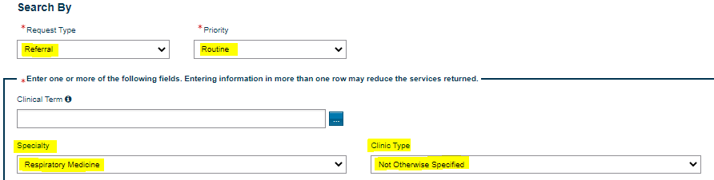  Search All

cid:image008.png@01D71B1A.555480E0

**Face to Face Assessment tool**

Clinical Assessment

1. History:

Dyspnoea

Fatigue

High Risk Groups include:

•Age 50 and over

•Age under 50 and

COPD

Diabetes / BM > 12mmol/l

BAME

Pregnancy

CVD/Hypertension

Obesity

Cancer

Chemotherapy

Immunocompromised

Learning disabilities

1. Vital signs: NEWS2 score
2. Examination – chest examination often normal

Green

**O2 95% or higher**

**Or any of RR ≤ 20, HR ≤ 90**

**≈ NEWS2 0-2**

if O2 sats are 1-2% less than usual

40 step walk test or one minute sit to stand test

No desaturation or 1-2%

Home with advice and consider referral

Amber

**O2 93 - 94%\***

**Or any of RR 21-24, HR 91-130**

**≈ NEWS2 3-4**

if O2 sats 3-4% less than usual

Consider Admission, Refer to AMU/AMRU consultant/AE

Red

**O2****92%* or lower**

**Or any of RR ≥ 25, HR ≥ 131, new confusion**

**≈ NEWS2 ≥ 5**

if O2 sats >4% less than usual

Admit by Ambulance/999

Start on Oxygen

if ≥ 3% reduction or clinical concern

*Oxygen saturations could be less than 94% at rest at baseline in patients with underlying respiratory/cardiac illness. Oxygen saturations could be falsely normal in some patients of BAME origin.

One minute sit to stand test can also be used to measure desaturation but is very labour intensive and clinical judgement is paramount.

1)

<https://www.nice.org.uk/guidance/ng165/resources/covid19-rapid-guideline-managing-suspected-or-confirmed-pneumonia-in-adults-in-the-community-pdf-66141902429125>

2) Consider individual wishes of the patient regarding care including advanced care plan when deciding on admission and have ReSPECT conversation if considering palliative care. 

<https://www.nice.org.uk/guidance/ng163/resources/covid19-rapid-guideline-managing-symptoms-including-at-the-end-of-life-in-the-community-pdf-66141899069893>

**Appendix 1:**

**Useful References**

<https://www.nice.org.uk/guidance/ng188/resources/covid19-rapid-guideline-managing-the-longterm-effects-of-covid19-pdf-66142028400325>

<https://www.gp-update.co.uk/SM4/Mutable/Uploads/pdf_file/Long-COVID-GEMS.pdf>

<https://www.bmj.com/content/bmj/370/bmj.m3026.full.pdf>

<https://www.guidelinesinpractice.co.uk/infection/top-tips-managing-long-covid/455742.article>

<https://elearning.rcgp.org.uk/course/view.php?id=416>

**Useful Tools**

Covid 19 Yorkshire Rehab Screen (C19-YRS)

<https://acnr.co.uk/2020/06/c19-yrs/>

Newcastle post-COVID syndrome Follow-Up Screening Questionnaire (see page 17)

<https://www.england.nhs.uk/coronavirus/wp-content/uploads/sites/52/2020/11/C0840-national-guidance-for-post-covid-syndrome-assesment-clinics-111220.pdf>

Post-Viral Fatigue A Guide to Management -British association for CFS/ME

[**https://www.bacme.info/sites/bacme.info/files/BACME%20Post%20Viral%20Fatigue%20A%20Guide%20to%20Management%20May2020.pdf**](https://www.bacme.info/sites/bacme.info/files/BACME%20Post%20Viral%20Fatigue%20A%20Guide%20to%20Management%20May2020.pdf)

**Patient Information**

How to conserve your energy: Practical advice for people during and after having COVID-19 (May 2020)



How to manage post-viral fatigue after COVID-19: Practical advice for people who have recovered at home (May 2020)



Manchester COVID-19 Recovery Peer Support Group: Poster/information



**Appendix 2**

**Services available in Trafford to support patients with Post-Acute**

**Covid-19 in the community (Tier 1 and Tier 2)**

|  |  |
| --- | --- |
| **Service** | **Referral route** |
| **Your Covid Recovery (Website) :** an online rehab service, Your Covid Recovery provides patients with information and advice on living with long Covid | **Self-access**  [**https://www.yourcovidrecovery.nhs.uk/**](https://www.yourcovidrecovery.nhs.uk/) |
| **Trafford Community Support Hubs:** Trafford Council has been working in partnership with a network of voluntary sector organisations and mutual aid groups throughout the pandemic. There are now 6 Community Support Hubs established across Trafford that can offer support to patients if they do not have support available through family, friends and neighbours.  •   Access to food and fuel  •   General wellbeing and helping patients to feel more socially connected  •   Understanding COVID advice and guidance  •   Advice on how to become digitally connected | **Community Response Line managed by Citizen’s Advice Trafford:** 0808 278 7803  **Web chat facility**: [**www.casort.org/help-through-web-chat**](http://www.casort.org/help-through-web-chat)**.** |
| **Covid-19 Peer Support group:** a weekly group which supports patients from across Greater Manchester who continue to suffer from Covid symptoms | **GP or Self-Refer**  [**mhcc.engagement@nhs.net**](mailto:mhcc.engagement@nhs.net) |
| **Community Care Navigators:** The care navigators work closely with NHS teams, GPs, social services (council), housing trusts, charities, voluntary groups, social enterprise organisations and other community resources to ensure residents are connected with the right services in their local neighbourhood. | Email: [**mft.carenavigators@nhs.net**](mailto:mft.carenavigators@nhs.net)  Phone: 0161 291 3659 |
| **Social Prescribing:** For residents who may be lonely, anxious or struggling with their mental health; or who require support with finances, relationships, or wider health related matters.  Social prescribers are available to talk these issues through and to connect people to the right advice and guidance, services and other local groups and organisations. | Refer via **neighbourhood social prescribing link workers** - referral as per arrangements within your PCN. |

**Appendix 3 - Referral pathway to access practical, psychological and mental health support post Covid**

**Client needs identified as:**

Refer to practice

**Social Prescribing link workers**

for further support

OR signpost to appropriate resources using links in document or message format



Financial

Social Isolation

Relationship

Substance Misuse

Other social

Client agrees to self-refer to Trafford Psychology Therapies (previously IAPT)

https://www.gmmh.nhs.uk/tpt/

Anxiety

Depression

Panic Attacks

OCD

Trauma

PTSD

Negative thinking patterns

Responsible Clinician refers to Trafford Psychological Therapies (F12 for referral form in EMIS)

For patients with additional complexities who may struggle to engage with talking therapy appointments currently and/or where diagnostic or medication advice beyond that available in primary care is needed

Responsible Clinician refers to Trafford Primary Care Mental Health and Wellbeing Service (F12 for referral form in EMIS)

Responsible Clinician refers to Community Mental health team -Mark referral

Emergency -for same day response (and telephone duty worker)

Urgent -for response within 5 days

Routine -for response within 20 days

For patients presenting with psychosis, significant paranoia or active suicide risk or otherwise meeting the criteria for CMHT

**Appendix 4**

**Copy of Post-Acute Covid Assessment Service referral template (to MFT South, Central and North sites)**

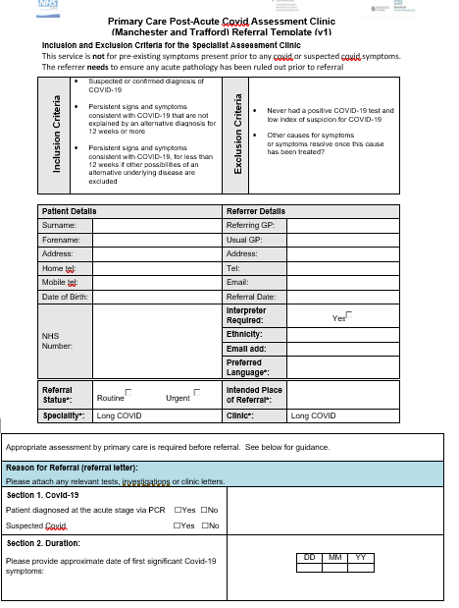

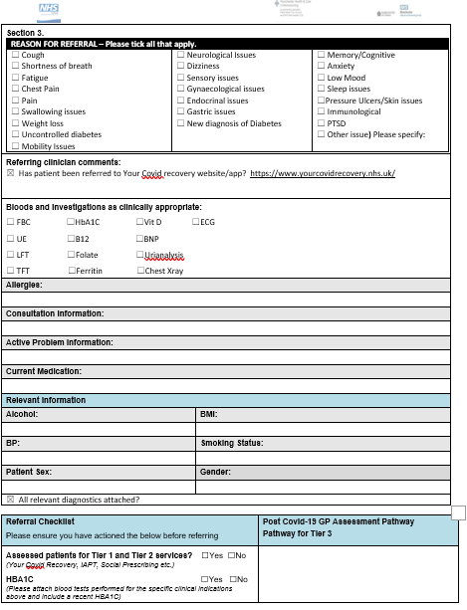



**Appendix 5**

**MFT Post-Acute COVID Referrals to Tier 3 Secondary Care Service**

GPs carry out investigations as indicated by symptoms and must include as a minimum:

1. Clear indication for the referral
2. Chest X-ray if breathless *(if CXR shows suspected lung cancer please refer via 2WW to cancer service)*
3. ECG
4. O2 sat at rest
5. Blood tests to include: FBC, UE, LFT, TFT, HbA1C, B12, Folate, Ferritin, Vit D, BNP, Urinalysis, ECG

**Triage/Holistic Assessment**

Nurse contact patient and discuss referral and undertake holistic assessment

Returned to GP if minimum criteria not completed

Refer to appropriate services as available:

Pulmonary Rehab, PARS, Care co-ordinators, Be well etc….

**Tier 4 Specialist MDT**

**Tier 3 Post COVID Clinic:**

NMGH, MRI or Wythenshawe

Arrange further tests and then virtual review again

Onward referral to other specialities

Discharge: Back to GP with care plan

**Virtual MDT Weekly**

Triage Nurse, Consultant and GP

(Admin to collect data/minutes etc)

Patients discussed and plan decided – appropriate person allocated as keyworker for outcomes

Refer to POST COVID CLINIC using referral template